GITHUB 3: Updating Lecture Notes

Before proceeding, make sure that you’ve read the file “Github2 Essentials.” Make sure that you’ve committed all outstanding changes.

- In the top panel go to the “Branch” tab. Click on the option “update from upstream/master”.

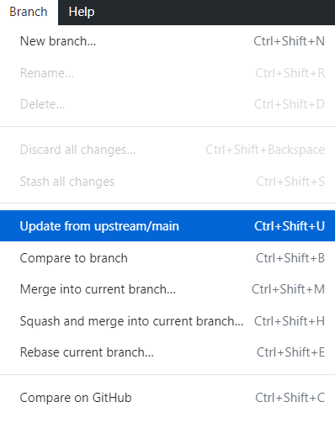

  - “upstream” refers to the original repository (the instructor’s)
  - “master” is usually the name given to the primary version of your repository.
Note: It’s also possible to create other intermediate branches where you or your collaborators can work in a change before merging it into the main.

Practical Advice:

- Try to do the updating process at the start of every class, to make sure you have the latest version.
- Store any modifications to the files with a separate file name. This avoids your files being overwritten by the instructor’s version when you do this process.
- Privacy: Right now, your forked repository is publicly visible on your account. If you want to change
  - Go to “Github.com”,
  - Find your forked repository page
  - Click on settings
  - Scroll down to the privacy settings and click on the privacy option. You will get a warning and just say yes. The warning is intended to prevent you from making it private if other users are actively drawing information from your repository.

